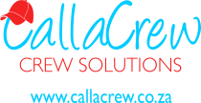 | 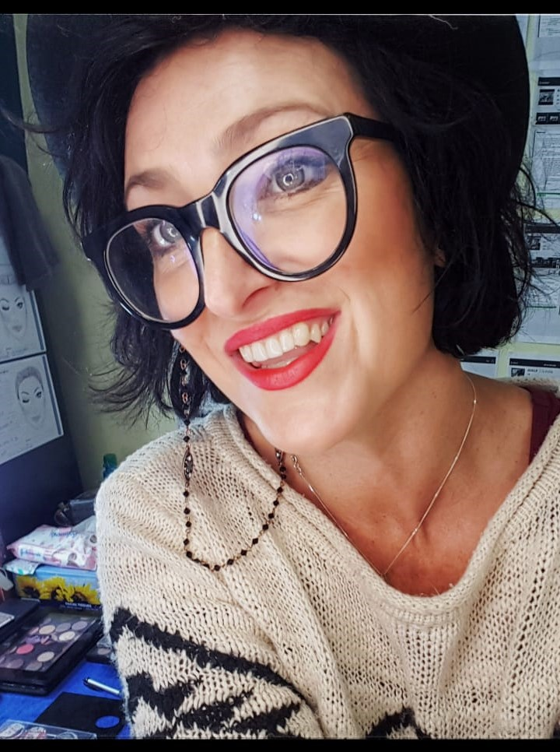  MARY-SUE MORRIS  WARDROBE / HAIR & MAKE-UP  Updated February 2020

I have been working in the industry for over 17 years, on amazing productions both Local and International, with some talented actors/crew/directors and producers, of which I’ve been nominated within my departments, and these productions has gone on winning awards in various categories.

Ive worked predominantly on Long form features, Series and Documentaries for the last couple of years, but I am also experienced in Commercials and Print!!

Being an absolute team player, I believe firmly that the day starts with Makeup and Costume, thus giving the actors/models a safe environment, helps set the mood and pace for the rest of the day, not only in film, but in every aspect of the creative industry

Why would you want me on your team?
Being a head Designer or Head of a department is the so called “easy” part of my job, but being able to spot a problem, assess the situation and come up with a realistic and fast solution, that is a skill set that sets me apart!!
I have a reputation of being a team player, working fast and staying within budget.

Finally, I am definitely FUN!!

NOMINATED for:
Achievement in Make-Up {AMAA 2018} for Lullaby Feature Film
SAFTA Nomination Makeup/Hair for Nul is nie niks nie Feature Film
SAFTA Nomination Costume for HOTEl TV series

Lullaby Film – Phoenix Films
*Milan International Filmmaker Festival {2018} – best Cine

Vir die Voëls
*Edmonton International Film Festival {2017} – International feature award

Meerkat Maantuig
*Calcutta International Cult Film Festival {2017} – Best Women’s Film
*International Childrens Film Fesival Brussels {2018} – Special Mention
*International Film Festival for Children and Young Audience Schlingel {2018} – FIPRESCI Jury Prize
Schlingel – best Feature Film
*Newport Beach Film Festival {2018} – Honors: Outstanding Achievement in Filmmaking
*Silwerskerm Festival {2017} – Best Cine
*South African Film and Television Awards {2019} – SAFTA Golden Horn – Best Cine

Mignon Mossie van Wyk {2016}
*Rahway International Film Festival {2016} – Festival Award – Best Cine
*The Richard Harris International Film Festival {2017} – Best Feature Film

Treurgrond {2015}
*Amsterdam International Filmmaker Festival {2018} – Best Cine
Trophy award – best foreign Language Film
*The Richard Harris International Film Festival {2016} – Best Feature Film

LONG FORM EXPERIENCE:

Production Co. | Production | Type | Position | Director/HOD
2019
Devil Speak | Tilogy | Discovery | Makeup/Hair/SFX | Designer/HOD
Alles Malan | Red Letter Productions | Television | Makeup/Hair | Desinger/HOD
Die Byl | Marche Media | Television | Makeup/Hair/SFX | Designer/HOD
Sara se Geheim 3 | Paw Paw Productions | Television | Makeup/Hair | Designer/HOD
Fynskrif | Infinity Films | Television | Makeup/Hair SFX | Designer/HOD
Banged Up Abroad | Trilogy | Discovery | Makeup/Hair | Stand in HOD
Still breathing | BBZee Films | Television | Costume: Replaced previous designer | “Fixer” designer/HOD
2018
Susters | Indigenous Films | Feature Film | Makeup/Hair | Designer/HOD
Mia and the White Lion -Block 4 | Galatee Films | Feature Film | Makeup/Hair/SFX | Designer/HOD
Stroomop | Film Factory | Feature Film | Costume | Designer/HOD
Vlieënde Springbokkie | Urban brew | Television | Costume | Designer/HOD
What lies beneath[Discovery Crime series] | Trilogy | Discovery | Makeup/Hair/SFX | Designer/HOD
2017
It’s Ok we’re Family | Endemol | Television | Makeup and Hair | Designer/HOD
Phil101 | Nouvanaand Produksies | Television | Costume | Designer/HOD
Hotel season 3 | Nouvanaand Produksies | Television | Costume | Designer/HOD
Sinawe Season 4 | Grey Matter Productions | Television | Costume/Hair/Makeup | Designer/HOD
Nul is nie Niks nie | Redhead Productions | Feature Film | Makeup/Hair/SFX | Designer/HOD
Empire of the sharks | Asylym | Feature Film | Costume | Designer/HOD
Meerkat Maantuig | Film Factory | Feature Film | Makeup/Hair/SFX/Costume | Designer/HOD
An Elephants Journey | Common Sense Media | Feature Film | Makeup/Hair | Daily
The Lullaby | Phoenix Films | Feature Film | Makeup/Hair/SFX/Costume | Designer/HOD
2016
Sinawe Season 2 | Grey Matter Productions | Television | Costume/Hair/Makeup | Designer/HOD
Vir Altyd | Film Factory | Feature Film | Makeup and Hair | Designer/HOD
Planet of the shark | Asylym
Mignon Mossie v Wyk | Phoenix Films | Feature Film | Makeup and Hair | Designer/HOD
Skorokoro | Phoenix Films | Feature Film | Makeup and Hair | Designer/HOD
Jou Romeo | Film Factory | Feature Film | Makeup/Hair/Costume | Designer/HOD
2015
Ballade vir ‘n Enkeling | Film Factory | Feature Film | Makeup and Hair | Designer/HOD
Treurgrond | Phoenix Films | Feature Film | Makeup/Hair and SFX | Designer/HOD
Trouvoete | Phoenix Films | Feature Film | Makeup/Hair and SFX | Designer/HOD
2014
Pad na jou hart | Film Factory | Feature Film | Costume | Designer/HOD
Suurlemoen |  | Feature Film | Costume | Designer/HOD
Spook van Uniondale | Movingbillboard Pictures | Feature Film | Costume | Designer/HOD
Land of milk and money | Phoenix Films | Television | Makeup/Hair and SFX | Designer/HOD
Die laaste Ure | Grey Cloud productions | Shortfilm | Costume | Designer/HOD
Leading Lady |  | Feature | Makeup/Hair | Daily
2013
Thomas @ TV | Kyknet | Television | Costume/Hair/Makeup | Designer/HOD

ACADEMIC/QUALIFICATION

Matric 2001
Various short courses in Makeup and Hair

REFEREES:

Claire Letoret 1st AD:072 540 8456
Franci van den Heever Production designer: 076 706 6040
Hanneke Schutte Director: 072 444 7879

